15.3 Across the period
Name: ____________________ Class: ____________________ Due date:
. Which property of elements increases across a period of the Periodic Table?（ ）
A metallic character
B number of electron shells
C number of outer shell electrons
D tendency to form positive ions

. W, X, Y and Z are elements in the same period in the Periodic Table.
W and Y are metals. X and Z are non- metals.
Which shows the correct order of these elements across the period?（ ）
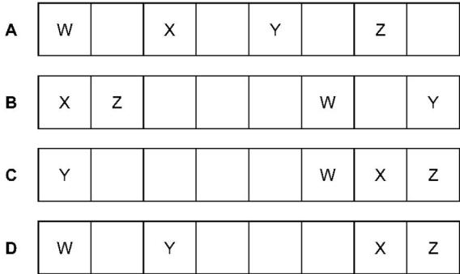

. Which element will be less reactive than the other members of its group in the Periodic Table?（ ）
A astatine B caesium C fluorine D rubidium
. The positions of four elements in the Periodic Table are shown.
Which element is a gas that displaces iodine from sodium iodide?（ ）
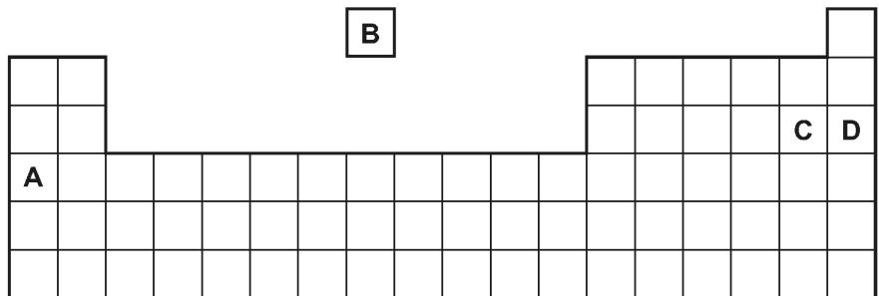

. A Group I metal (lithium, sodium or potassium) is reacted with a Group VII element (chlorine, bromine or iodine).
Which compound is formed when the Group I metal of highest density reacts with the Group VII element of lowest density?（ ）
A lithium chloride B potassium chloride C potassium iodide D lithium iodide
. Which statement about Group I and Group VII elements is correct?（ ）
A Group VII elements are monatomic non- metals.
B Lithium is more reactive with water than caesium.
C The melting points of Group I metals increase down the group.
D Potassium bromide reacts with chlorine to produce an orange solution.

. Five elements have proton numbers 10, 12, 14, 16 and 18.
What are the proton numbers of the three elements that form oxides?（ ）
A 10, 12 and 14
B 10, 14 and 18
C 12, 14 and 16
D 14, 16 and 18

. The diagram shows an outline of the Periodic Table.
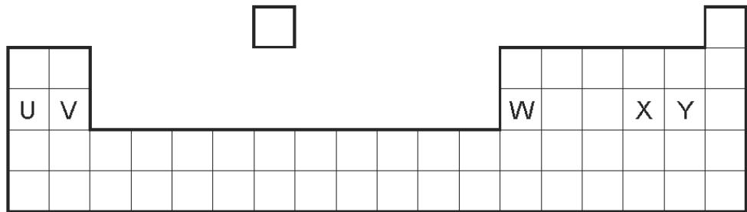
Which of the elements U, V, W, X and Y would react together in the ratio of 1:1?（ ）
A U and X B U and Y C V and Y D W and X

. The element rubidium, Rb, is immediately below potassium in the Periodic Table.
It reacts with bromine to form the compound rubidium bromide.
Which descriptions of this compound are correct?（ ）
 | type of bond | formula | colour
A | covalent | RbBr | brown
B | covalent | RbBr₂ | white
C | ionic | RbBr | white
D | ionic | RbBr₂ | brown

25 .Calcium, on the left of Period 4 of the Periodic Table, is more metallic than bromine on the right of this period.
Why is this? Calcium has . （ ）
A fewer electrons.
B fewer protons.
C fewer full shells of electrons.
D fewer outer shell electrons.

49. The Periodic Table lists all the known elements. Elements are arranged in order of …….1. .. number. The melting points of Group I elements …….2. .. down the group. The melting points of Group VII elements …….3. .. down the group.
Which words correctly complete the gaps 1, 2 and 3?（ ）
 | 1 | 2 | 3
A | nucleon | decrease | increase
B | nucleon | increase | decrease
C | proton | decrease | increase
D | proton | increase | decrease

51. J and K are two elements from the same period in the Periodic Table.
The table gives some properties of J and K.
 | J | K
appearance | shiny grey | dull yellow
electrical conductivity when solid | good | poor
malleability | malleable | brittle
Which statement about J and K is correct?（ ）
A J forms an acidic oxide.
B J is found to be the left of K in the Periodic Table.
C K forms positive ions when it reacts.
D K is more metallic than J.

54. The diagram shows elements W, X, Y and Z in a section of the Periodic Table.
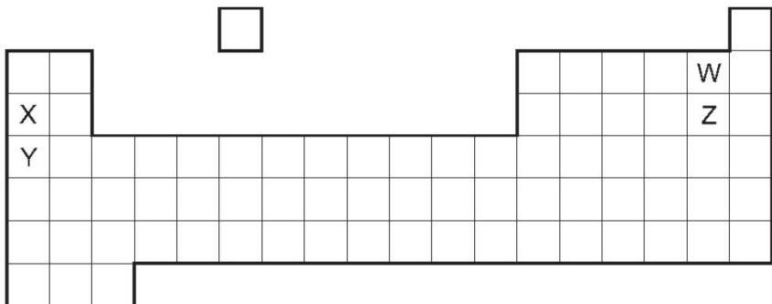
Which statement about the reactivity of the elements is correct?（ ）
A X is more reactive than Y, and W is more reactive than Z.
B X is more reactive than Y, and Z is more reactive than W.
C Y is more reactive than X, and W is more reactive than Z.
D Y is more reactive than X, and Z is more reactive than W.

55. Hydrogen and helium have both been used to fill balloons.
Which property of helium makes it the preferred choice to hydrogen? （ ）
A easily compressed into a gas cylinder
B forms monatomic molecules
C lower density
D unreactive

58. Where in the Periodic Table is the metallic character of the elements greatest? （ ）
 | left or right side of a period | at the top or bottom of a group
A | left | bottom
B | left | top
C | right | bottom
D | right | top

69. Chromium forms the compound chromium(III) sulfate.
What does the (III) represent? （ ）
A the charge on a sulfate ion
B the number of chromium ions combined with one sulfate ion
C the number of sulfate ions combined with one chromium ion
D the oxidation state of chromium

74 .Which element is less reactive than the other members of its group in the Periodic Table?（ ）
A astatine B caesium C fluorine D rubidium

80. Which statement about nitrogen and phosphorus is not correct?（ ）
A Both are in the same group of the Periodic Table.
B Both are in the same period of the Periodic Table.
C Both are non- metals.
D Both have the same number of electrons in their outer shell.

81. A period of the Periodic Table is shown.
group | I | II | III | IV | V | VI | VII | VIII
element | R | S | T | V | W | X | Y | Z
The letters are not their chemical symbols.
Which statement is correct?（ ）
A Element R does not conduct electricity.
B Elements R and Y react together to form an ionic compound.
C Element Z exists as a diatomic molecule.
D Element Z reacts with element T.

89. Which statement about the Periodic Table is correct?（ ）
A Elements in the same group have the same number of electron shells.
B It contains elements arranged in order of increasing proton number.
C Metals are on the right and non- metals are on the left.
D The most reactive elements are at the bottom of every group.

96 .Part of the Periodic Table is shown.
Which element forms an oxide that reacts with dilute acid to form a salt and water?（ ）
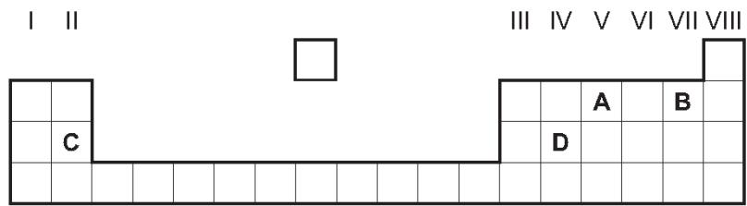

103. Which statement about elements in Group I and Group VII of the Periodic Table is correct?（ ）
A Bromine reacts with potassium chloride to produce chlorine.
B Iodine is a monatomic non- metal.
C Lithium has a higher melting point than potassium.
D Sodium is more reactive with water than potassium.

122 .Period 3 of the Periodic Table contains the elements sodium to argon. Element Q is a non- metal from this period.
Which statement about Q is correct?（ ）
A It conducts electricity.
B It has a lower proton number than sodium.
C It has electrons in only three shells.
D It is malleable.

124. Elements P and Q have the same number of electron shells.
Q has more electrons in its outer shell than P.
Which statements are correct?（ ）
1 P and Q are in the same group of the Periodic Table.
2 P and Q are in the same period of the Periodic Table.
3 P has a greater tendency to form positive ions than Q.
4 The oxides of Q are more basic than those of P.
A 1 and 3 B 1 and 4 C 2 and 3 D 2 and 4

125. Which row about elements in the Periodic Table is correct?（ ）
 | statement 1 | statement 2
A | two elements in the same group have similar chemical properties | metals are on the left of the table
B | two elements in the same group have similar chemical properties | metals are on the right of the table
C | two elements in the same period have similar chemical properties | metals are on the left of the table
D | two elements in the same period have similar chemical properties | metals are on the right of the table

The table below includes information about some of the elements in Period 2.
element | carbon | nitrogen | fluorine | neon
symbol | C | N | F | Ne
structure | macromolecular | simple molecules N₂ | simple molecules F₂ | single atoms Ne
boiling point/℃ | 4200 | -196 | -188 | -246
Why does neon exist as single atoms but fluorine exists as molecules?
What determines the order of the elements in a period?
When liquid nitrogen boils the following change occurs.
$$N_{2}(I)→N_{2}(g)$$
The boiling point of nitrogen is very low even though the bond between the atoms in a nitrogen molecule is very strong. Suggest an explanation.
Draw a diagram showing the arrangement of the outer shell (valency) electrons in a molecule of nitrogen.

5. For each of the following, select an element from Period 4, potassium to krypton, which matches the description.
$M(OH)_{2}$A metal that reacts rapidly with cold water to form a compound of the type and hydrogen.
..................................................................................................................................[1]
Its only oxidation state is .......................................................................
$XO_{2}$It has a macromolecular oxide, , which has similar physical properties to those of diamond.
..................................................................................................................................[1]
This is one of the metals alloyed with iron in stainless steel. ..............................[1]
$X^{−}$It can be reduced to an ion of the type . ..............................[1]
$H_{2}X$It can form a covalent hydride having the formula ............................... [1]
Its soluble salts are blue and its oxide is black. ..............................[1]
It is a liquid at room temperature. ..............................[1]

8 - (0620- S 2013- Paper 4 (Extended)/1- Q2) - ACIDS AND BASES, THE PERIODIC TABLE
$2+8+18+3$An element, M, has the electron distribution
Which group in the Periodic Table is element M likely to be in?
...................................................................................................................................[1]
Predict whether element M is a poor or a good conductor of electricity. Give a reason for your answer.
..............................................................................................................................[1]
Binary compounds contain two atoms per molecule, for example HCl. Identify an element which could form a binary compound with element M.
.................................................................................................................................[1]
${SO}_{4}^{2−}$Predict the formula of the sulfate of M. The formula of the sulfate ion is
..................................................................................................................................[1]
The hydroxide of M is a white powder which is insoluble in water. Describe how you could show that this hydroxide is amphoteric.
..................................................................................................................................[2]
.......................................................................................................................................[2]

9. For each of the following, name an element which matches the description.
It is used as a fuel in nuclear reactors....................................................... [1]
It is the only non-metal which is a good conductor of electricity............................ [1]
Inert electrodes are made from this metal....................................................... [1]
This gaseous element is used to fill balloons in preference to hydrogen. ...............[1]
$X^{3−}$An element which can form an ion of the type . ............................................[1]
$Ca^{2+}$It has the same electron distribution as the calcium ion, . ...........................[1]
The element is in Period 5 and Group VI. ......................................................[1]

14 . For each of the following elements give one physical property and one chemical property.
$({Br}_{2})$bromine
physical property .................................................................................................
chemical property.......................................................................................... [2]
carbongraphite(C)
physical property .................................................................................................
chemical property .................................................................................................[2]
manganese (Mn)
physical property .................................................................................................
chemical property .................................................................................................[2]

16. The table below shows the elements in the third period of the Periodic Table, the number of electrons in their outer energy level, their oxidation state in their common compounds and their melting points.
element | Na | Mg | Al | Si | P | S | Cl | Ar
number of outer electrons | 1 | 2 | 3 | 4 | 5 | 6 | 7 | 8
oxidation state | +1 | +2 | +3 | +4/-4 | -3 | -2 | -1 | 0
melting point/℃ | 98 | 650 | 660 | 1414 | 317 | 115 | -101 | -189
Describe and explain the variation in oxidation state across the period.
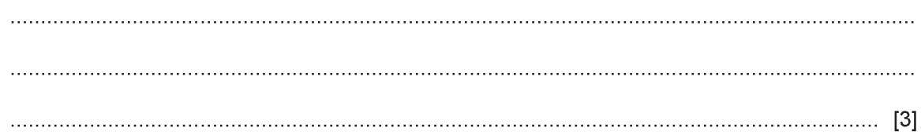
The first three elements, Na, Mg and Al, are metals.
Describe the structure of a typical metal.
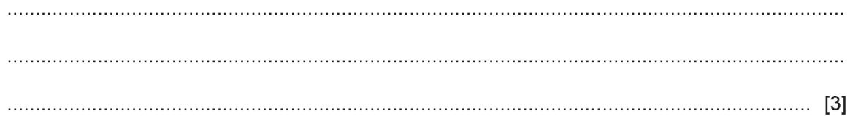
Explain why Na, Mg and Al are good conductors of electricity.
.........................................................................................................................................................................................................................................................................[1]
$X_{2}$Which element exists as diatomic molecules of the type ?
.........................................................................................................................................................................................................................................................................[1]
Silicon has a similar structure to diamond.
Explain why silicon has the highest melting point in the period.
.......................................................................................................................................................................................................................................................................[2]
Sodium chloride is a crystalline solid with a high melting point. It dissolves in water to give a neutral solution. Phosphorus trichloride is a liquid at room temperature. It reacts with water to form an acidic solution.
Suggest an explanation for these differences in properties.
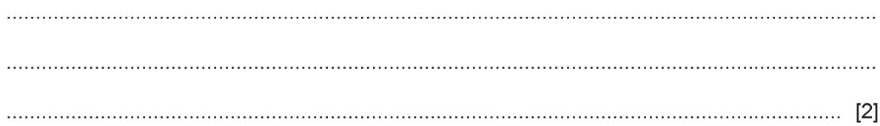
Describe how you could show that magnesium oxide is a basic oxide and not an amphoteric oxide.
Draw a dot-and-cross diagram showing the bonding in magnesium oxide. Show outer electrons only.

23. This question is about the elements in Period 3 of the Periodic Table.
Na | Mg | Al | Si | P | S | Cl | Ar
For each of the following, identify a Period 3 element which matches the description. Each element may be used once, more than once or not at all.
State which Period 3 element:
forms an oxide with a macromolecular structure ...........................................[1]
is extracted from the ore bauxite ...........................................[1]
is soft, metallic and stored in oil ...........................................[1]
is a green gas at room temperature and pressure ...........................................[1]
provides an inert atmosphere in lamps........................................... [1]
forms two different oxides during the Contact process................................... [1]
is non-metallic and an important component of fertilisers................................. [1]

